**PROJECT 2**

REQUIREMENT SPECIFICATION

Billy Kong

Objective: Interface that provides properties and their information. Tracks the status of properties and whether they are still on the market. Allows you to purchase and browse real estate listings.

Program will display a friendly user interface that will allow users to browse and purchase real estate properties. Properties will be selected and information pertaining to the property will be displayed. Non property specifics such as – Owner information, agent information and offers for the property will be available as well. The interface will be displayed as described, drop-down box that displays the property addresses. Once an address has been chosen, the required information for the specific property will be displayed. User will then be able to purchase or make an offer on the selected property.

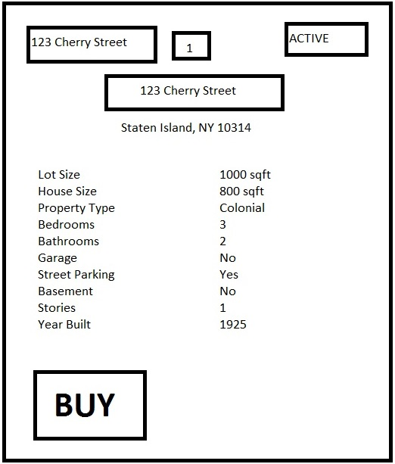

Database will store information following a specific address. For example, a certain address will be selected, the program will only bring up information pertaining to that address. Information stored in the database will be organized following the address name.

Database will store the information:

**Filter** – Allows listings to be filtered by state

**Address** (only information specific to the address will be displayed)

* City
* State
* Zip code
* Listing ID number – specific ID number for property listing
* Description – brief description of the property
* Buying price – cost to purchase the property
* Renting price – monthly cost to rent the property
* House Size – total square foot of housing
* Lot Size – total square foot of property
* Stories – stories of housing
* Style – housing style
* Bedrooms – number of bedrooms
* Bathrooms – number of bathrooms
* Garage – does the property include a garage
* Street Parking – parking facilities availability
* Basement – condition of basement
* Year Built – year housing was built
* Status of property – sold / available

**Owner**

* Name
* Address
* Phone number
* Email
* Name of realtor

**Realtor link**

* Name of realtor
* Realtor comments
* Status

**Offers**

* Name
* Amount
* Conditions

NEW:

Credit Card Acceptance / Information Prompt

- Allows you to select your credit card provider

- Information is needed to verify if the card is authentic

- Will then process that the property has been purchased

REGISTRATION

* + - Allows you to register your own listing in the database and in the interface